|  |  |
| --- | --- |
|  | Faculty of Information Science and Technology  Universiti Kebangsaan Malaysia  43600 Bangi Selangor |
| **TTTK2103**  **Computer Network Technology** | |

**PACKET TRACER**

4.6.5 Packet Tracer – Connect a Wired and Wireless LAN

|  |  |
| --- | --- |
| **Name** | **Matrix Number** |
| Mariam binti Masuan | A182976 |
| Mohamad Saiful Nizam bin Abd Aziz | A179830 |

## Part 1: Connect to the Cloud

## Part 2: Connect Router0

## Part 3: Connect Remaining Devices

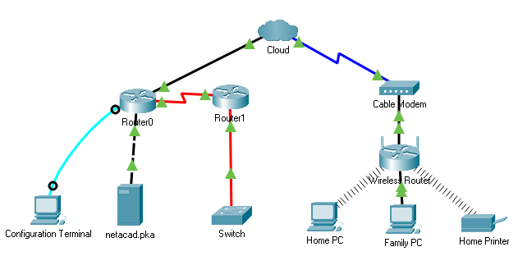

## Part 4: Verify Connections

### Test the connection from Family PC to netacad.pka.

* + 1. Open the **Family PC** command prompt and ping **netacad.pka**.

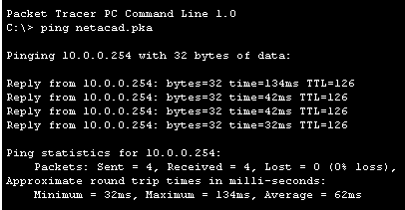

b. Open the **Web Browser** and the web address **http://netacad.pka**.

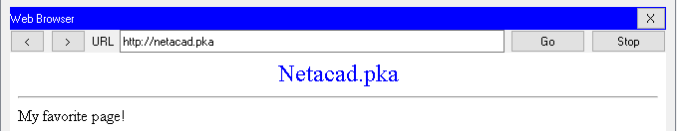

### Ping the Switch from Home PC.

Open the **Home PC** command prompt and ping the **Switch** IP address of to verify the connection.

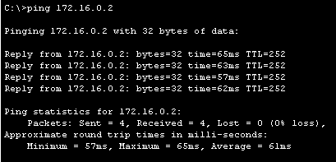

### Open Router0 from Configuration Terminal.

Type **show ip interface brief** to view interface statuses.

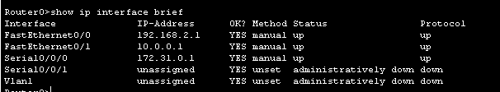

## Examine the Physical Topology

### Examine the Cloud.

How many wires are connected to the switch in the blue rack?

Answer: 2 wires.

### Examine the Primary Network.

* + 1. Click the **Primary Network** icon. Hold the mouse pointer over the various cables.

What is located on the table to the right of the blue rack?

Answer: Configuration Terminal

### Examine the Secondary Network.

* + 1. Click the **Secondary Network** icon. Hold the mouse pointer over the various cables.

Why are there two orange cables connected to each device?

Answer: Fiber cables come in pairs, one for transmit, the other for receive.

### Examine the Home Network.

* + 1. Click the **Home Network** icon.

Why is there no rack to hold the equipment?

Answer: Home networks typically do not have racks.